FL8. Lesson 2. Basic css.

Homework

1. The result of your work should be packed to **folder** with html and css files, and inner folder structure should be exactly as follows:

*|__ homework_02 /*

*|__ img/  
 |__ css /*

*|__*.css*

*|__ index.html*

1. Code has to be well-formatted, and validated via validator
2. The folder must be loaded into the Github repository '**front-end-lab-8**' in the **master** branch
3. Code should contain comments, with number of task

**Hometask:**

You will see files which represent almost finished site. We have restriction at this point: you **should not change** any provided **styles** and **html** (even global styles in index.html) but you can **add new styles** in **style.css** . Take a look to the site. Open it in browser.

1. Send html page to **print** (press ctrl/cmd+p in browser). You should see print preview now. Something like this:

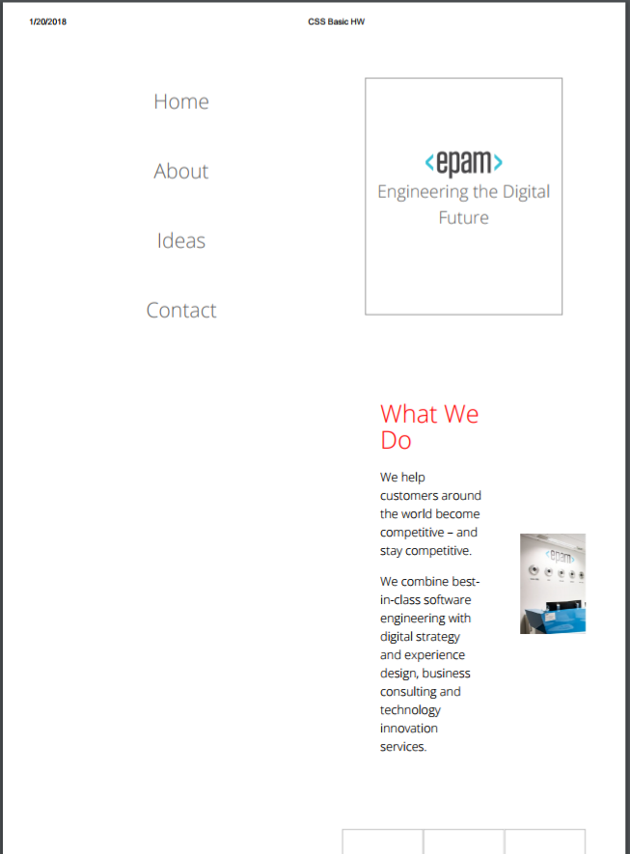

Your task is: fix print version. Result should look like this (not pixel perfect):

2. Lets look closer at this part of site

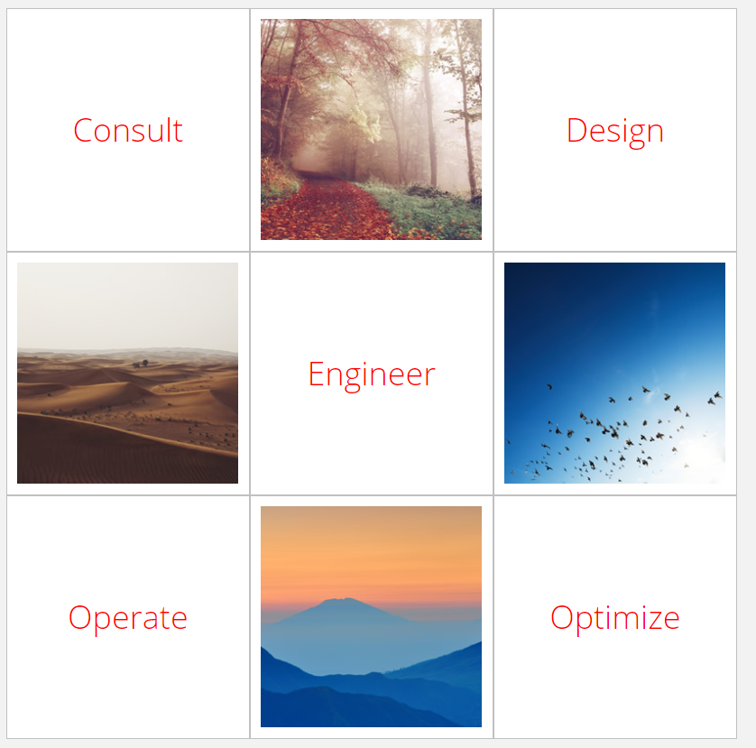

As you see each tile has a border and there is some overlap of borders, e.g. bottom border of first tile overlaps with top border of fourth tile. See image below. Your task is rid of this overlapping

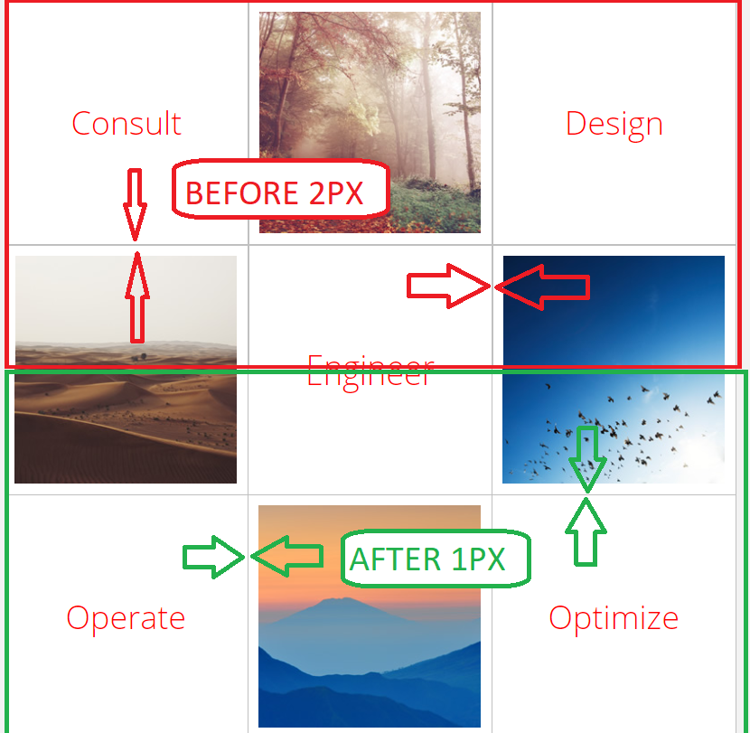

3) Change color of first letter in each paragraphs to 76cdd7, Font size to 30px

4) Add box shadow to sidebar and each content block

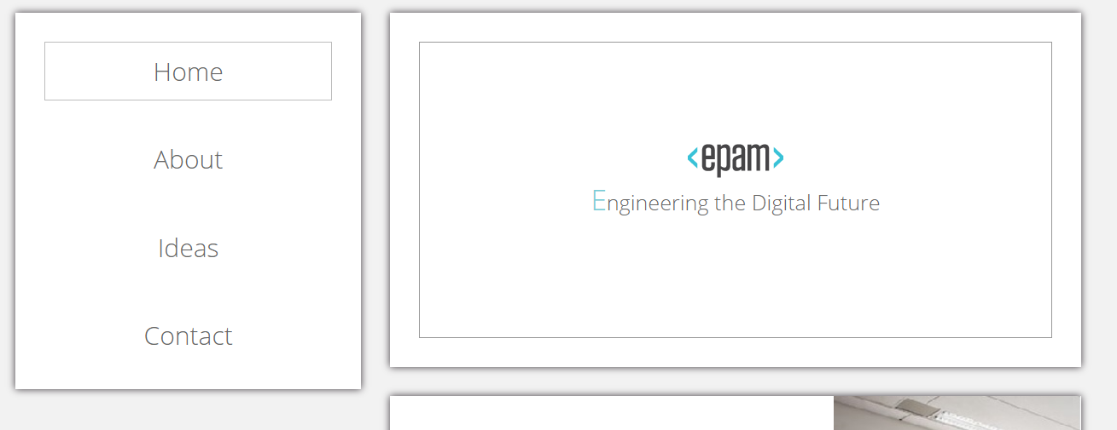

5) Add silver border to each img which is in <a> tag in gallery-container 2px width

6) Change color of ‘How We Do It’ to gainsboro and add letter spacing 5px

7) Each first paragraph which placed after h2 tag should have italic font style

8) Text in paragraph should look like in image below. (vertical space between lines is increased, there is some free space at start of first line)



But text in first banner block should not have such styles



9) Style next content block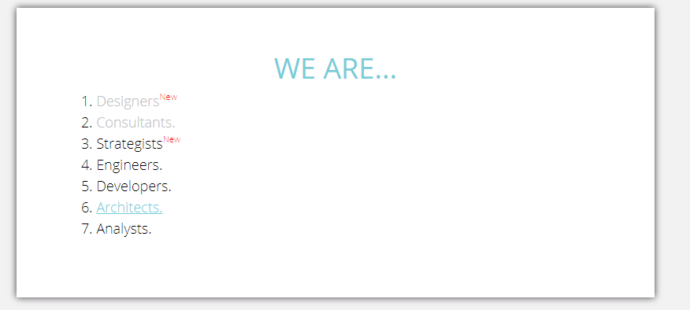

Visited links should become silver color, hover link should be like 6. item

10) Add layout and styles for following block.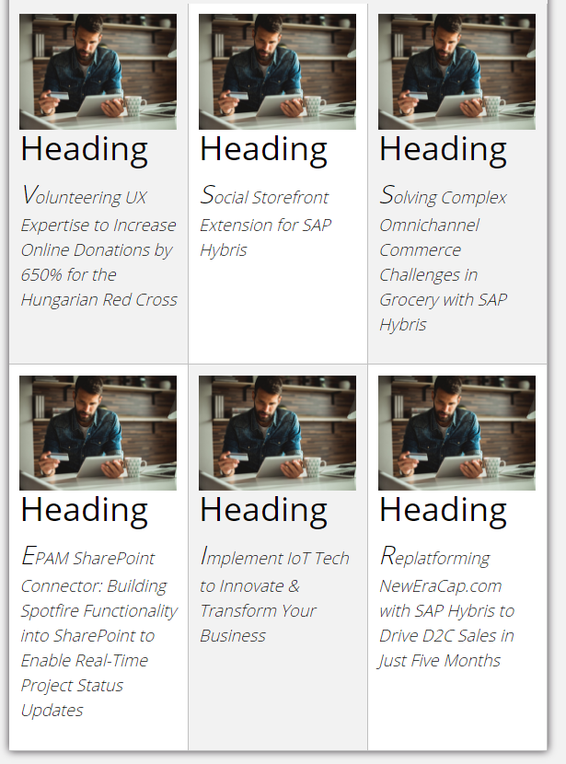

11) Take a look to sidebar. We need silver border on the bottom side of all list item. But last one should not have such border.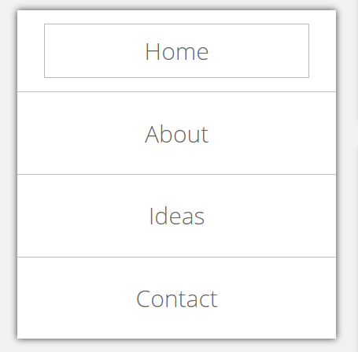

12) Change text color in text input and submit button to red. Use attribute type selector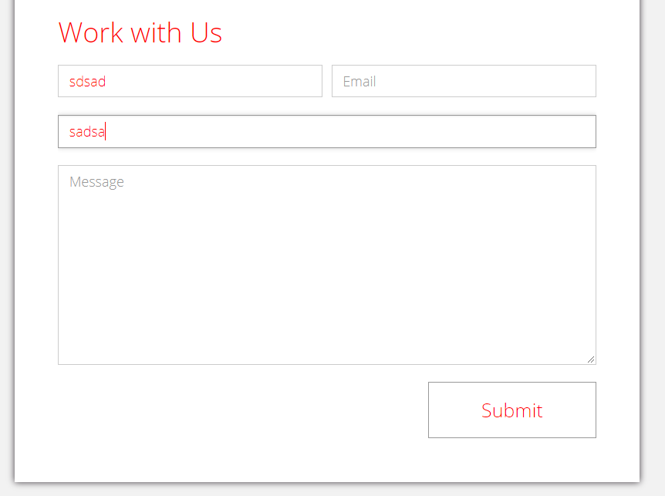

13) Extra task. make sidebar adhered to the top of the page if we have not enough free space for it. See the link. Please note that you need to consider both the lack of a free width and height. Sidebar should become sticky when width of page is less than 1140px OR height of the page less than 835px. You can find helpful information from this link <https://developer.mozilla.org/en-US/docs/Web/CSS/Media_Queries/Using_media_queries>

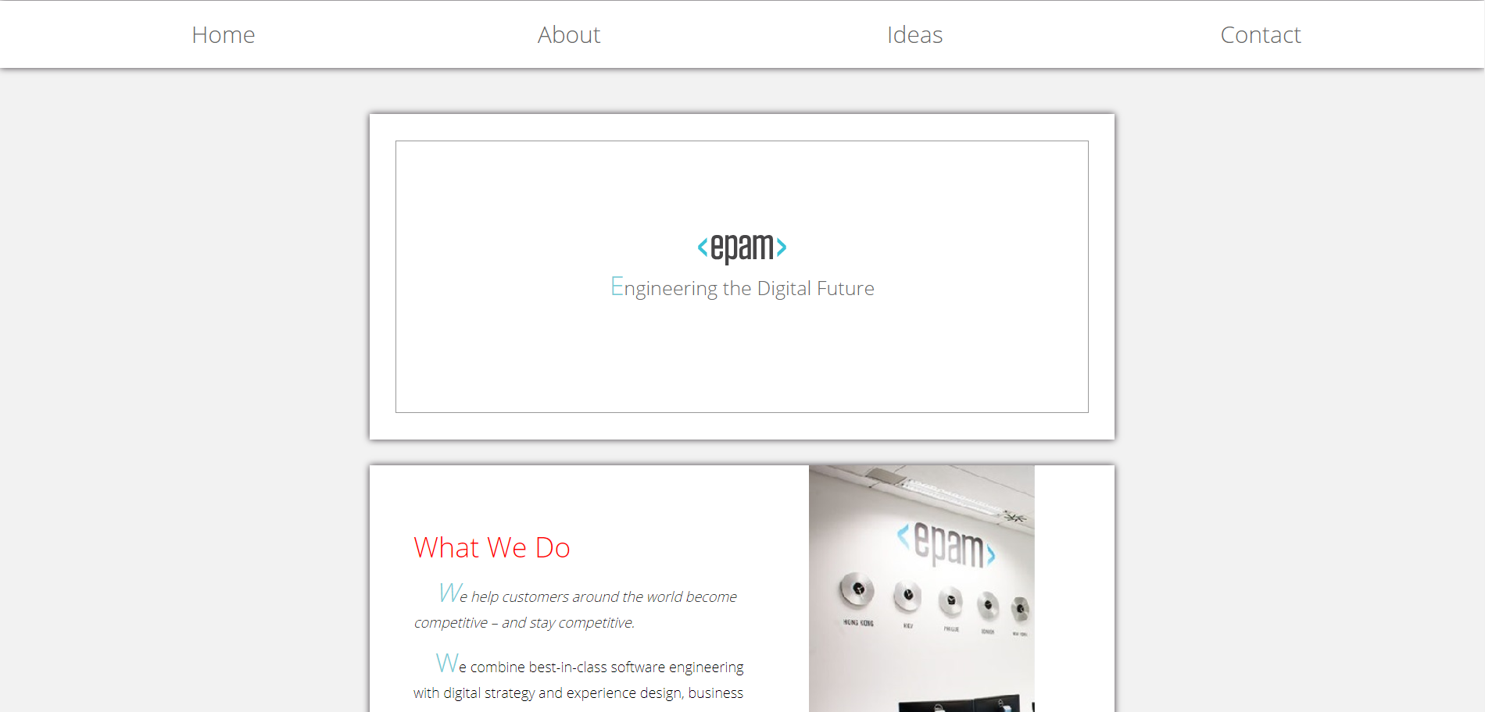

Note: **This task is not necessary to implement.**